**WIA2001/WIB2001**

**DATABASE**

**SEM 1, 20116/2017**

**Tutorial 5**

1. How is the concept of functional dependency associated with the process of normalization?
2. Answer the following questions based on the table below:

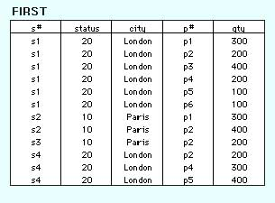

|  |  |
| --- | --- |
| s# | supplier identification number (this is the primary key) |
| status | status code assigned to city |
| city | name of city where supplier is located |
| p# | part number of part supplied |
| qty | quantity of parts supplied to date |

1. Identify the functional dependency from the table above.
2. Normalize the table above until 3NF
3. Examine the table shown below.

| *branchNo* | *branchAddress* | *telNo* | *mgrStaffNo* | *name* |
| --- | --- | --- | --- | --- |
| B001 | 8 Jefferson Way, Portland, OR 97201 | 503-555-3618 | S1500 | Tom Daniels |
| B002 | City Center Plaza, Seattle, WA 98122 | 206-555-6756 | S0010 | Mary Martinez |
| B003 | 14 – 8th Avenue, New York, NY 10012 | 212-371-3000 | S0145 | Art Peters |
| B004 | 16 – 14th Avenue, Seattle, WA 98128 | 206-555-3131 | S2250 | Sally Stern |

1. Why is this table not in 3NF?
2. Describe and illustrate the process of normalizing the data shown in this table to third normal form (3NF).
3. Identify the primary, (alternate) and foreign keys in your 3NF relations.